**Triggering builds with webhooks behind a secure firewall**

This is an OSS project provided by GitHub and also helpfully hosted as a service by GitHub. This can capture and forward webhooks for jenkins server.

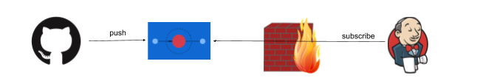

GitHub pushes an event to Smee.io and Jenkins in turn subscribes to Smee with an outgoing connection from a client. Jenkins only makes an outbound connection.

Step 1. Start a new Smee channel

To help GitHub send webhooks to your local machine without exposing it to the internet, you can use a tool called Smee. First, go to https://smee.io and click Start a new channel.

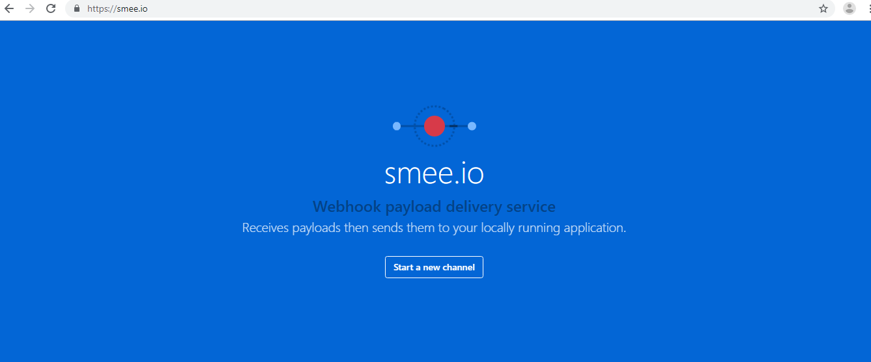

Starting a new Smee channel creates a unique domain where GitHub can send webhook payloads.

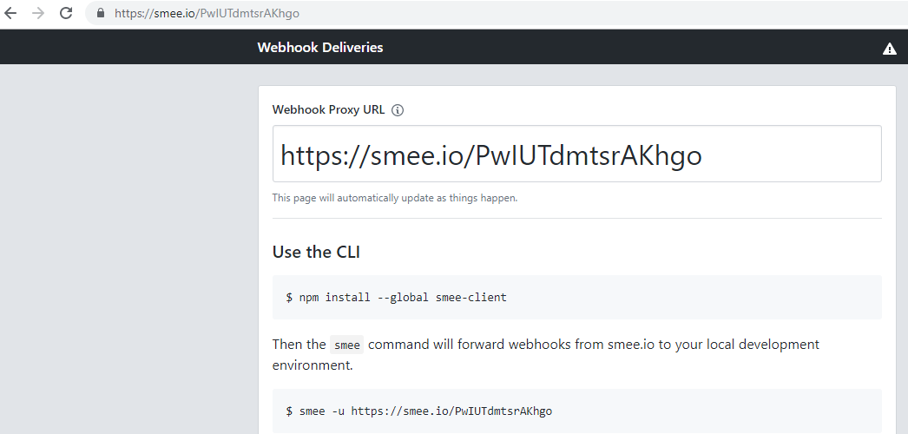

Next, go back to the Terminal (windows PowerShell ) and follow these steps to run the Smee command-line interface (CLI) client:

Note: windows PowerShell – run as administrator

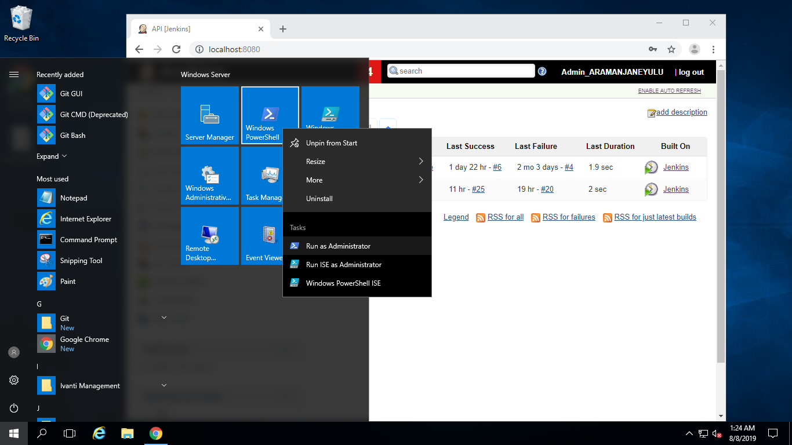

1. Install node js –v8.12.0

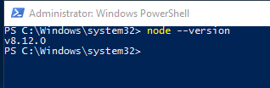

2. we should install the smee client next to where we have the Jenkins server running:



3. Run the client (replacing https://smee.io/PwIUTdmtsrAKhgo with your own domain)

smee -u [https://smee.io/PwIUTdmtsrAKhgo--path /github-webhook/ --port 8080](https://smee.io/PwIUTdmtsrAKhgo--path%20/github-webhook/%20--port%208080)

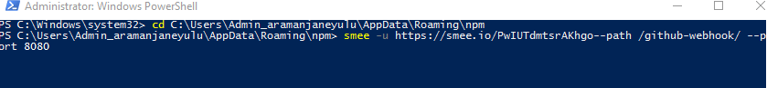

You should see output like the following:



**Step 2. Github**

Go to the settings tab for your GitHub repository, and then click “add webhook”:

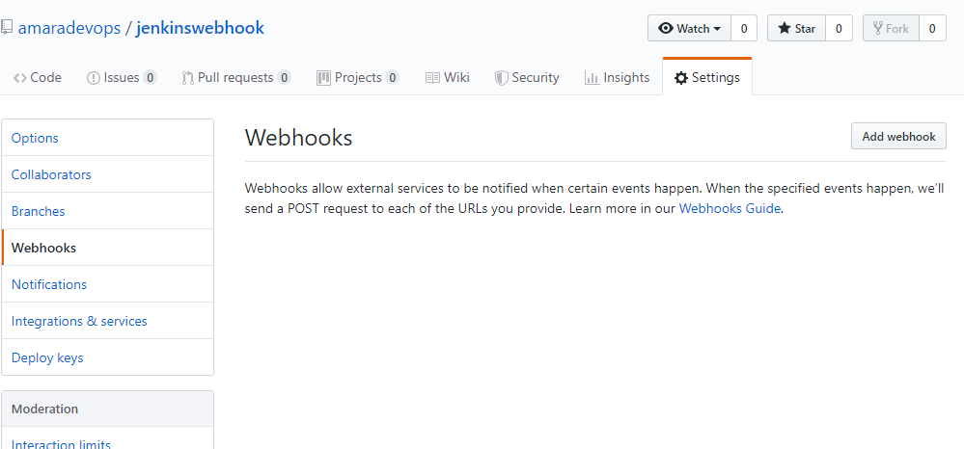

Next, configure the webhook:

* Paste in the “smee” URL you copied from the step above.
* Choose application/json as the content type
* Tell it to send everything (you can pick and choose what events, but I just did that as simpler).
* Press Add Webhook (or update)

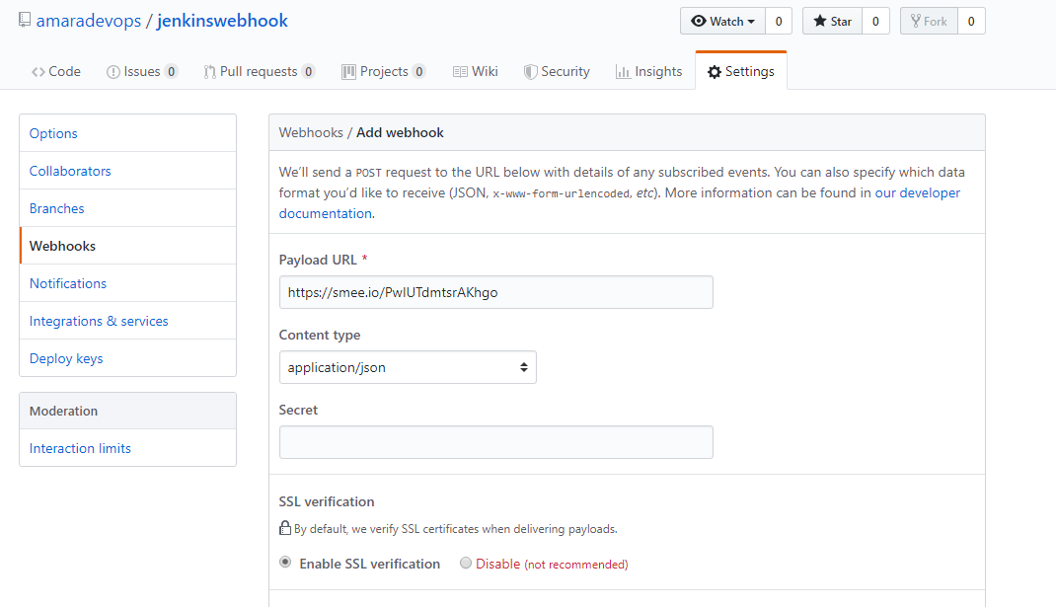



OK - webhooks should be flowing now. You can make a change to your repository, and check that a build starts soon after

**Jenkins job:**

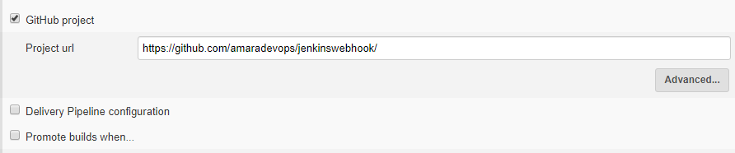

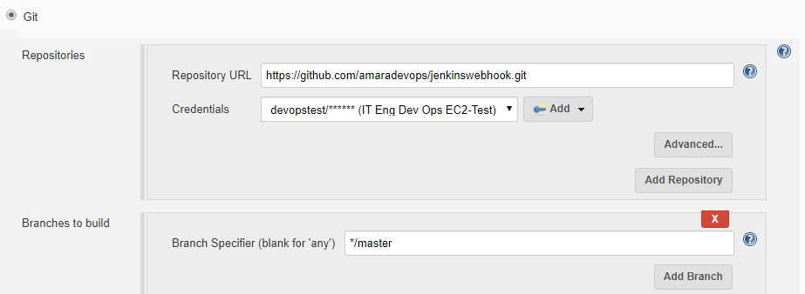



Developer will find a directory where they'd like to store the code. Run this command to clone

git clone <https://github.com/amaradevops/jenkinswebhook.git>

